**SOPFIM Project : Requirements of Message application**

To modify in the DataGrid the user must click in “Nouveau” or “Modifier”

* “Nouveau” : means create a new message from the last message entered;
* “Modifier” : means modify the message you enter the number;

In this windows, the current message in number 1.

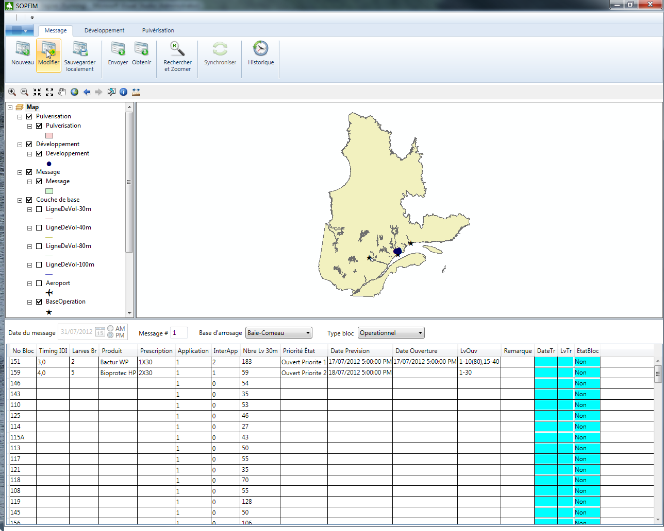

Click in “Modifier and enter “1”;

1. **Entering a valid date**

Try to enter Data in “Date Prevision” or “Date ouverture”. The hour must be all the time 5:00AM or 5:00PM.

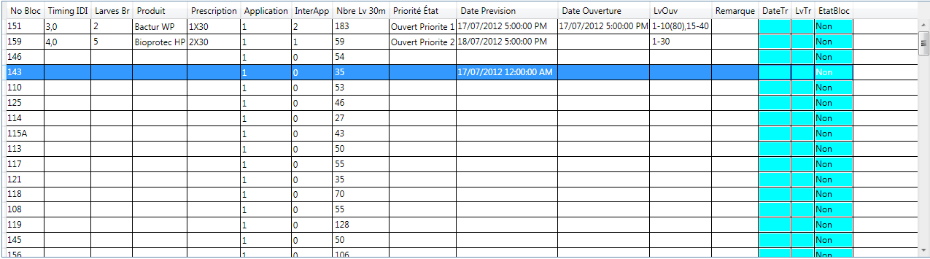

1. **Clearing a date**

The user should be able to cancel the entry of a date.

1. **Zoom to the current bloc**

The user should be able to zoom to a bloc when he select a record in the grid, click in the columns “No Bloc” and click in “Zoom in”

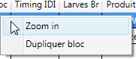

1. **Duplicate the current bloc**

The user should be able to duplicate a record in the grid (a bloc), click in the columns “No Bloc” and click in “Dupliquer bloc”



***Notice :*** Other processing should be done in fields LvOuv and Date Ouverture. This is will be explained in another requirement.

1. **The data entered in the grid is saved in FeatureClass “message” correctly**

Ensure that the data enterd in DataGrid are correctly saved in FC ‘Message’. The button “Sauvegarder localement” means save locally.



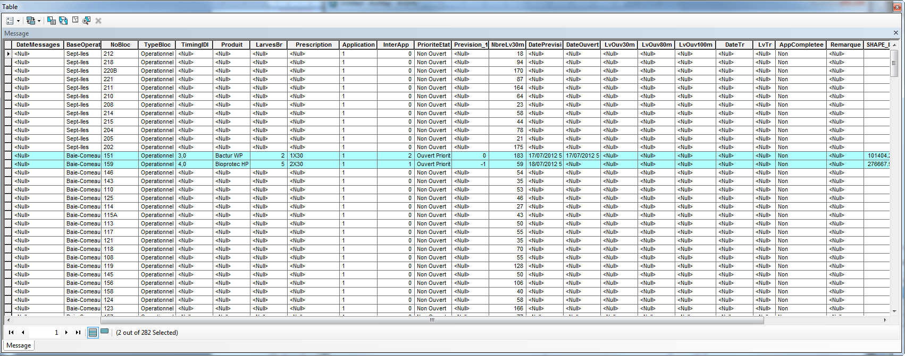

1. **Entering “Date Ouverture” field**

When a user enters “DatePrevsion” than DateOuverture must be empty. When a user enters “DateOuverture” then DatePrevision should be cleared. We should not have in a record the two fields populated.

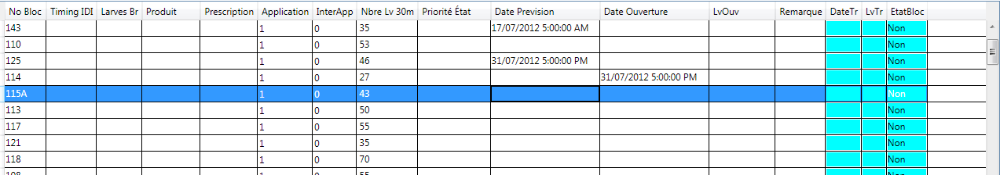

1. **Creating flight lines**

This requirement needs a good understanding of the data model and the code related to “Lignes de vol”.

In the last code (mobile plateform), the application used the FC “BufferLvTBE” to show the flight lines “lignes de vol” related to each bloc.

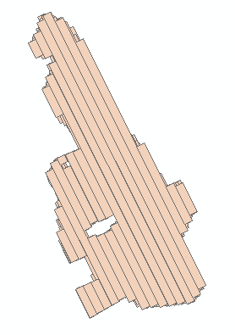**Polygones in BufferLvTBE**

In the new code you have, the application create the flight lines “ligne de vol” on the fly (Polygons) using 4 FeatureClass of polylines:

LvTBE100 : LigneDeVol-100m

LvTBE80 : LigneDeVol-80m

LvTBE40: LigneDeVol-40m *(actually nothing in the FeatureClass)*

LvTBE30: LigneDeVol-30m

**100m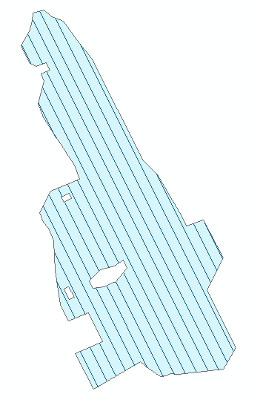 80m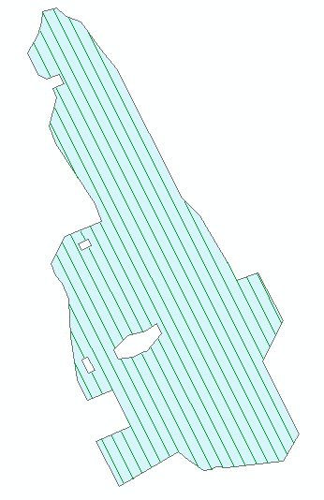 30m**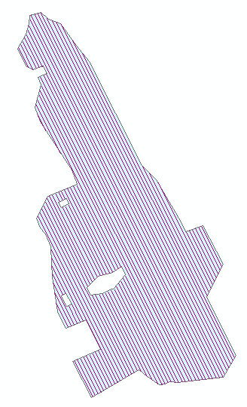

The “**LvOuv**” field in featureclass “message” contain information about the flight lines. To enter data, the syntax is :

***n1-m1(x1),n2-m2(x2),....n6-m6,n7,n8(x8),....***

*ni =1, 2, 3, ...*

*mi = 1,2, 3...*

*ni, mi <= NbreLV30*

*xi = 30,40, 80 or 100*

*n6-m6 : idem n6-m6(30)*

*n7 : idem n7(30)*

***samples :***

*1-10(80),11,12-14(80),15-40*

*1-15,16-35(80),36(100)*

Ensure that the flight lines are created according to the formula entered in the field “LvOuv” with no overlapping.

To see the result, you have to save and then zoom in to the bloc.

1. **Drawing categories for flight lies**

This requirement needs a good understanding of the data model and the code related to “Lignes de vol”.

To be continued...